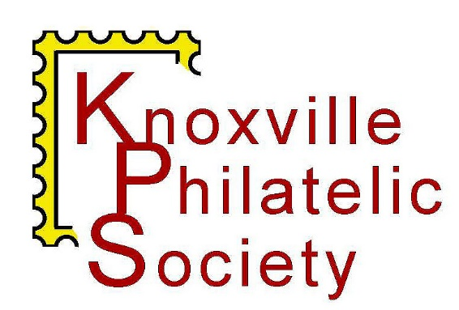
Invites you to
KnoxPEx 2026
March 7-8, 2026

KPS is proud to host its annual show, KnoxPEx 2026, with a theme that honors
Revolutionary War General Henry Knox

- Rothchild Catering – 8807 Kingston Pike, Knoxville 37923
- 10-5 Saturday with live auction at 6; 10-3 Sunday
- Parking and Admission are Free
- Show cachet and postal cancel
- 12 dealers
- Live Auction

KnoxPEx 2026 is sponsored by Daniel F. Kelleher Auctions, LLC, one of the world’s greatest philatelic auction houses.
www.kelleherauctions.com

Dealers in the KnoxPEx 2026 bourse

C & D Philatelics
Charlie Hamilton
PO Box 158
Ruby VA 22545-0158
540-729-3387
chamil302@aol.com
Postal History, Military Covers, Naval Cancels, Better First Day Covers and Space Covers

Carolina Stamp & Coins
Tony Crumbley
PO Box 681447
Charlotte NC 20216
704-395-1191
tcrumbley2@bellsouth.net
Covers – Confederate stamps – Postal History

Jared Cassidy Stamps
Jared Cassidy
PO Box 502
Huntsville AL 35804
256-337-0077
jared@jaredcassidy.com
United States – British Commonwealth – Ireland

First Century of Stamps
Dennis O'Brien
2229 Fenway Farms Trail
Fenton MO 63026
314-809-9554
firstcenturystamps@gmail.com
US & worldwide classic era stamps

HB Philatelics
Guy Gasser
PO Box 2320
Florissant MO 62032
314-330-8684
guy@hbphilatelics.com
Quality United States – CSA – Possessions – Hunting Permits – Proofs and Essays

Daniel F. Kelleher, LLC
22 Shelter Rock Lane, Unit 53
Danbury, CT 06810
203-830-2500
info@kelleherauctions.com
Worldwide philatelic auctions

Leo Stamps
Leonardo Palencia Norciso
105 Killdeer
Leander TX 78641
512-999-4911
gypleo@yahoo.com
Worldwide stamps and covers 1840-1960

Match & Medicine & More
Randall Chet
46 Deer Hollow Lane
Zirconia, NC 28790
828-699-4331
matchandmedicine@gmail.com

Northern Light Stamps
Drew Fountain & Jim Butler
4095 Chamblee Tucker Rd
The theme of KnoxPEx 2026 is Revolutionary War General Henry Knox. At the age of 25, Knox was tapped by General George Washington to take a small contingent in early 1776 to recover canons from the recently captured Fort Ticonderoga. Knox and his team brought the canons to Boston, where Washington’s troops were besieging the British garrison. With the much-needed artillery, the British evacuated in two weeks.
Knox went on to play important roles in Washington’s crossing of the Delaware River and in the Battle of Yorktown. After overseeing the War Department under the Articles of Confederation (1785-1789), Knox was selected by President Washington to be Secretary of War (1789-1794).
In 1790, President Washington appointed North Carolinian, William Blount
governor of the “Territory South of the River Ohio. A year later, Blount named
the new territorial capital Knoxville, after Henry Knox.
The KnoxPEx 2026 cachet shows a portrait of Henry Knox. The stamps on
the cachet are the Henry Knox stamp, issued by the USPS in 1985 and the
Boston 2026 Exposition stamp issued in 2025.
Learn more about the Knoxville Philatelic Society at www.knoxstamps.com
Atlanta, GA 30340
770-377-3849
drewfountain@gmail.com

Rusty Shoaf
40 Tuscany Ct
Lafayette, IN 47905
317-289-7696
rusty.shoaf@rshoaf.com
Worldwide postal history, British Commonwealth (through 1960), Germany

Stamp Center of Texas
Kurt Harding
39350 Interstate 10 West #5
Boerne TX 78006
210-240-4083
Stampmeister55@gmail.com
US and worldwide stamps, covers, souvenir sheets

KS Philatelics
Kurt Streepy
PO Box 228
Smithville, IN 47458
812-320-9174
www.ksphilatelics.com
Worldwide first issues, Canal Zone and US possessions

Swan Classic, LLC
Cass S Rejent, III
PO Box 71657
Marietta, GA 30007-1657
770-330-0790
info@swanclassic.com
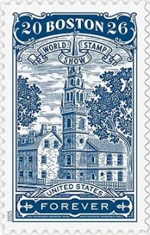
World Wide Classic Stamps from 1840-1940
